

GRADE 8. RESPONSE TO LITERATURE

📚 Integrated Lesson Plan: The Mozart Question, Qur’anic Reflection & Gaza

🎯 Learning Objectives
- Understand the emotional and ethical themes of The Mozart Question
- Reflect on the role of memory, silence, and survival in times of oppression
- Explore how the Qur’an offers healing and moral clarity
- Draw connections between historical trauma and current events in Gaza
- Develop empathy, critical thinking, and spiritual awareness

🕰️ Lesson Structure (60–75 minutes)

1. Starter Activity: Silent Reflection (10 min)
- Display the colour-in image of the child in Gaza with the toy jet.
- Ask students to sit quietly and reflect: “What do you think this child is feeling? What might the toy jet represent?”
🧠 Prompt for journaling: “Sometimes silence speaks louder than words. What does this silence say?”

2. Literary Exploration: The Mozart Question (15 min)
- Recap the story of Paolo Levi and his parents’ silence about Mozart.
- Discuss how music became both a lifeline and a burden.
📖 Quote for analysis: “We played Mozart while people died. And we survived. But we never played again.”
💬 Discussion Questions:
- Why did Paolo’s parents stop playing music?
- What does survival mean when others suffer?

3. Spiritual Integration: The Qur’an as Healing (15 min)
🕋 Verse Reflection: “And We send down of the Qur’an that which is healing and mercy for the believers…”— Surah Al-Isra (17:82)
- Discuss how Muslims turn to the Qur’an for emotional and spiritual healing.
- Compare the role of music in the play to the role of Qur’anic reflection in Muslim life.
💬 Discussion Questions:
- How does the Qur’an help us process pain?
- What does the Qur’an teach us about remembering suffering with dignity?

4. Contemporary Connection: Gaza’s Genocide (15 min)
- Share age-appropriate facts about the humanitarian crisis in Gaza.
- Emphasize the suffering of children, the destruction of homes, and the global silence.
🧠 Life Lesson Questions:
- What does the child in Gaza have in common with Paolo Levi?
- How can we use our voices to stand for justice?
- What does Islam teach us about responding to oppression?
🕯️ Qur’anic Anchor: “Indeed, Allah commands justice and the doing of good…” — Surah An-Nahl (16:90)

5. Creative Response: Colour & Reflect (15–20 min)
- Students colour in the image of the child with the toy jet.
- On the back, they write a short reflection: “What does this image teach me about pain, memory, and hope?”

🧭 Extension Ideas
- Create a class mural titled “Voices of Memory” with quotes, verses, and student reflections.
- Invite students to write a letter to a child in Gaza expressing empathy and solidarity.
- Pair with a Qur’anic memorization activity on verses about justice and mercy.

📝 Grade 8 Notes: The Mozart Question by Michael Morpurgo

📖 Overview
The Mozart Question is a poignant story about Paolo Levi, a gifted violinist, whose music is intertwined with a painful family history rooted in the Holocaust. Through a journalist’s interview, we uncover how music—especially Mozart—was used in concentration camps, and how Paolo’s parents survived by playing in the camp orchestra.

🎭 Key Themes
- Music as Memory and Healing: Music is both a source of trauma and a path to healing.
- Silence and Secrets: Paolo’s family kept their past hidden, showing how silence can protect but also isolate.
- Art and Ethics: The story raises questions about using beauty (Mozart’s music) in horrific contexts.
- Resilience and Identity: Paolo’s journey reflects how we reclaim our identity through truth and courage.

🧠 Discussion Points
- Why was Paolo forbidden to play Mozart?
- How does music help people survive emotionally?
- What does the story teach us about history and remembrance?

✍️ Vocabulary
- Holocaust – The genocide of Jews during WWII.
- Orchestra – A group of musicians playing together.
- Concentration Camp – A place where people were imprisoned under harsh conditions.
- Resilience – The ability to recover from difficulties.

📄 Worksheet: Exploring The Mozart Question

Part 1: Comprehension
- Who is Paolo Levi and what makes him special?
- Why does Paolo hesitate to speak about Mozart?
- What role did music play in his parents’ survival?
- How does the journalist’s approach help Paolo open up?

Part 2: Reflection
- Write a short paragraph: “If I could ask Paolo one question, it would be…”
- Imagine you are a musician in the camp. What emotions would you feel while playing?

Part 3: Creative Colour-In Activity 🎨
Instructions: Below is a description of a scene for students to colour.
Encourage students to use warm colours for hope and cool tones for sorrow. This visual metaphor helps encapsulate the emotional duality of the story.
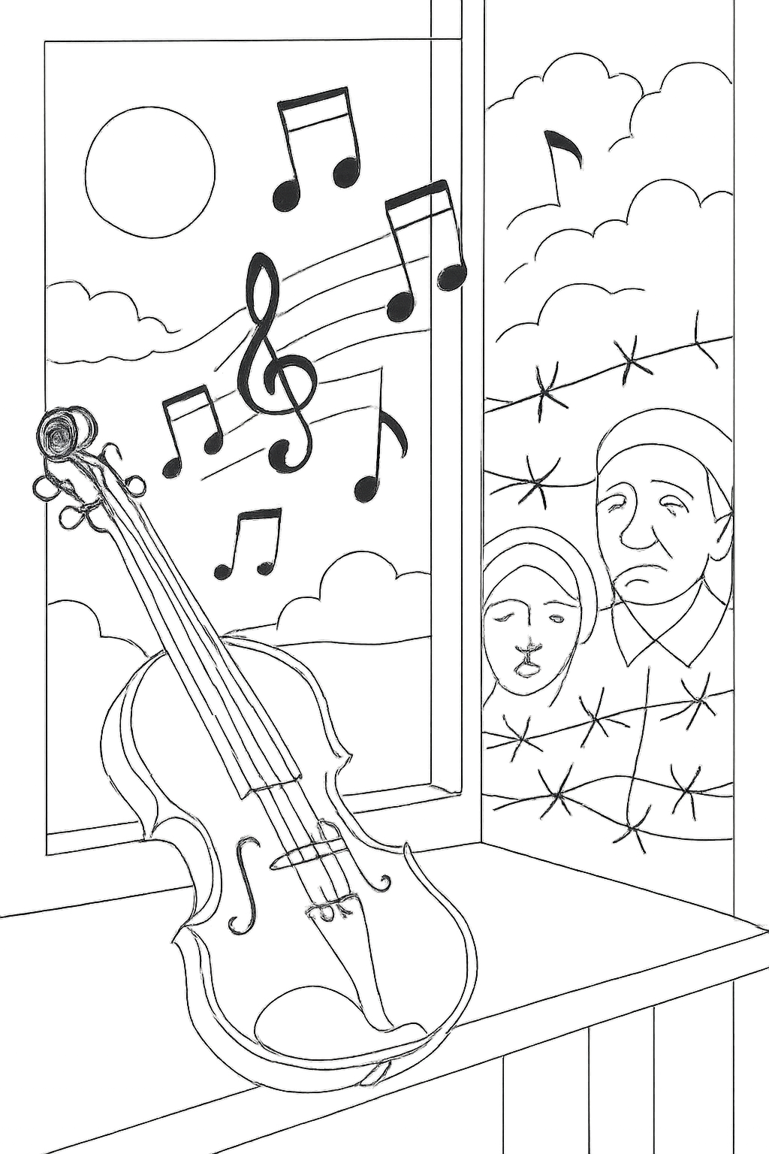

Here is a picture of a child in Gaza that I tried to connect with the play. The aeroplane, a toy, is a stimulus for horror because of the bombing and the music notes are not soothing at all – what do you think it symbolises? Maybe all the peace treaties that turned out to be a failure.

Write a dialogue between Signor Levi and a child from Palestine.

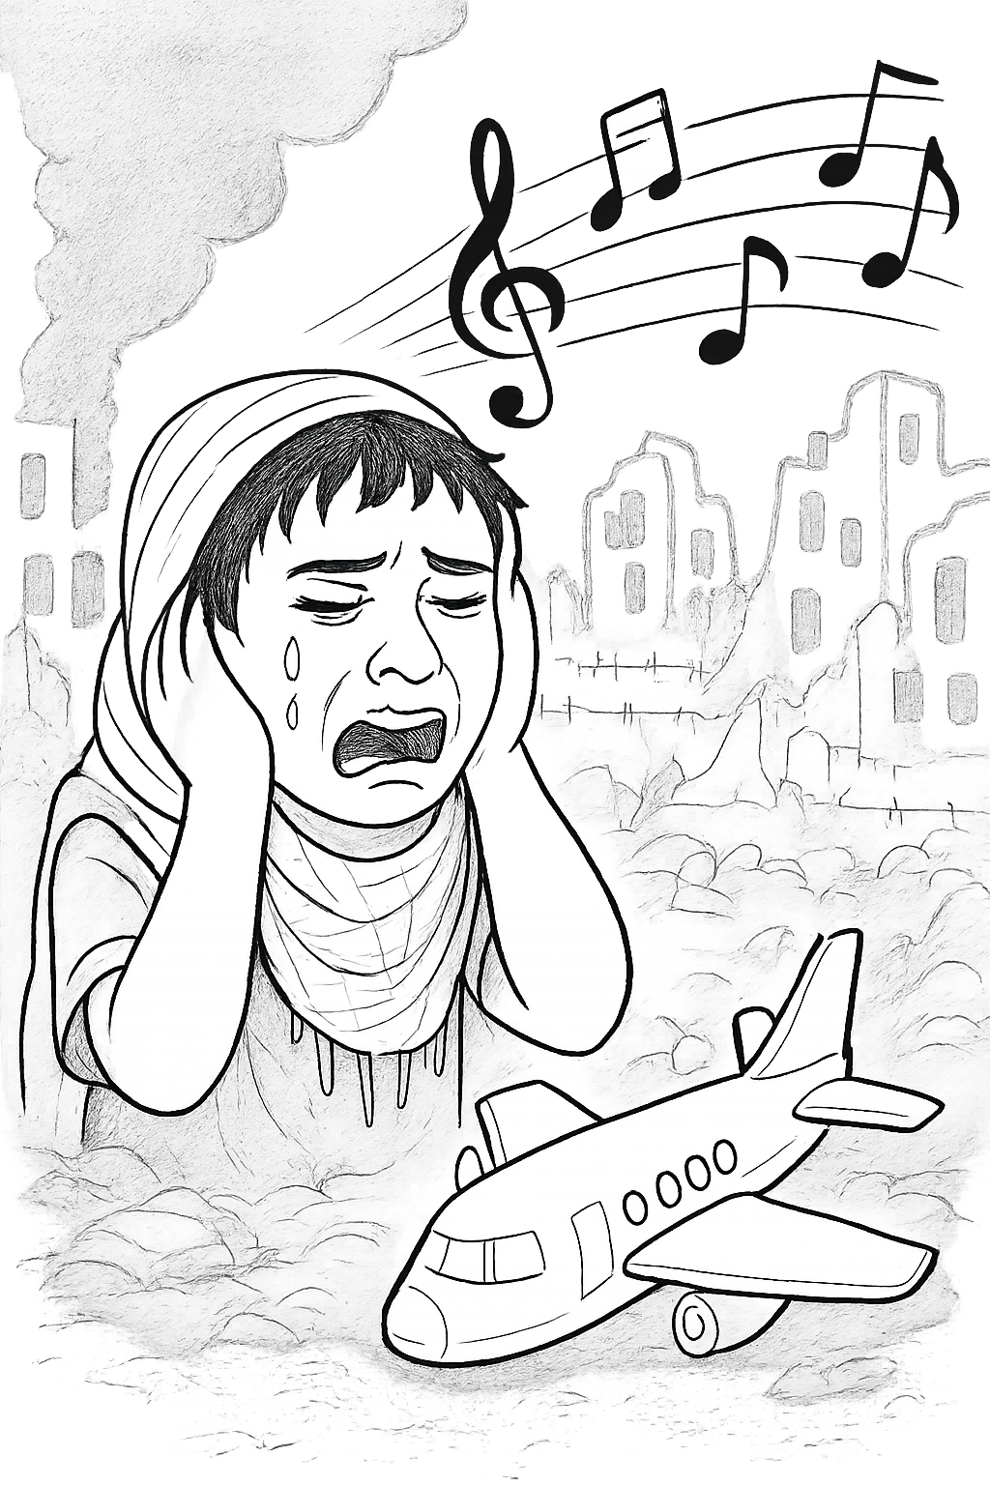

✅ Worksheet Answers: The Mozart Question

Part 1: Comprehension
- Who is Paolo Levi and what makes him special? Paolo Levi is a talented violinist known for his emotional and expressive playing. What makes him special is not just his skill, but the powerful story behind his music—especially his connection to Mozart and his family's past.
- Why does Paolo hesitate to speak about Mozart? Paolo hesitates because Mozart’s music is tied to a painful family history. His parents were forced to play Mozart in a concentration camp orchestra during the Holocaust, and for many years, they avoided speaking about it.
- What role did music play in his parents’ survival? Music, especially Mozart, was used by the Nazis in the camps. Paolo’s parents survived because they were musicians and were forced to play in the camp orchestra. While it saved their lives, it also became a symbol of trauma and guilt.
- How does the journalist’s approach help Paolo open up? The journalist shows empathy and patience, allowing Paolo to feel safe enough to share his story. She listens without judgment and gives him space to speak, which helps him finally reveal the truth about his past.

🌱 Life Lesson Questions for The Mozart Question

🎻 On Silence and Secrets
- Why do some families choose to keep painful memories hidden?
- Can silence protect us—or does it sometimes prevent healing?

🎼 On Music and Meaning
- How can music carry both beauty and pain at the same time?
- What role does art play in helping people survive difficult experiences?

🕊️ On Forgiveness and Understanding
- Should Paolo’s parents feel guilty for surviving through music?
- How can we learn to forgive ourselves for choices made in hard times?

🧠 On Identity and Courage
- What does Paolo’s decision to finally play Mozart say about his growth?
- How do we find the courage to speak our truth, even when it hurts?

🌍 On History and Responsibility
- Why is it important to remember stories like Paolo’s?
- What can we do today to make sure the pain of the past isn’t repeated?

🌙 Spiritual Reflection: The Holy Qur’an as a Source of Healing and Meaning
While The Mozart Question explores how music helped Paolo’s parents survive trauma, Muslims turn to the Holy Qur’an as their ultimate source of comfort, guidance, and reflection.

🕋 Key Points to Share with Students
- The Qur’an as a Healing Source Allah says in Surah Al-Isra (17:82): “And We send down of the Qur’an that which is healing and mercy for the believers…” This verse reminds us that the Qur’an soothes the heart, especially in times of pain and confusion.
- Reflection Through Recitation Just as Paolo found meaning through music, Muslims find peace through tilawah(recitation), tadabbur (deep reflection), and du'a (supplication). The rhythm and beauty of Qur’anic verses offer emotional and spiritual clarity.
- Memory and Legacy The Qur’an preserves the stories of past nations, prophets, and trials—not to entertain, but to teach, warn, and inspire. It helps us remember the suffering of others with compassion and responsibility.
- Ethical Anchoring Unlike music, which can be interpreted in many ways, the Qur’an provides a clear moral compass. It teaches us how to respond to injustice, how to forgive, and how to remain hopeful.

🧠 Life Lesson Question (Faith-Based)
- How can the Qur’an help us process pain and injustice in the world today?
- What does the Qur’an teach us about remembering the suffering of others with dignity and purpose?
- How does reflecting on the Qur’an differ from using art or music to understand emotions?

In The Mozart Question, Signor Levi’s story reveals how music was used in Nazi concentration camps, and how survivors carried the trauma of being forced to play while others suffered. It’s a haunting reminder of how beauty can be twisted, and how silence can protect—but also imprison.
Today, in Gaza, we witness another chapter of human suffering. According to recent reports, nearly 60,000 Palestinians, including thousands of children, have been killed since October 7, 2024. Families are bombed, starved, and buried under rubble while the world debates terminology and diplomacy13. Just as Signor Levi’s parents were forced to play Mozart in the camps, children in Gaza are surrounded by destruction—yet they cling to toys, stories, and faith as fragile lifelines.

🕯️ Life Lesson Parallel: From Levi to Gaza

🎻 Signor Levi’s Lesson
“We played Mozart while people died. And we survived. But we never played again.”

✈️ Gaza’s Echo
A child clutches a toy jet in the ruins, not to glorify war, but to imagine escape. Their silence is not forgetfulness—it’s survival.

🧠 Reflective Questions for Students
- What does it mean to survive when others do not?
- How do children in Gaza today reflect the pain Paolo Levi carried?
- Why must we remember suffering—not to dwell in it, but to prevent its repetition?
- How can we use our voices, faith, and actions to stand for justice?

🌙 Islamic Perspective: Memory and Mercy
The Qur’an teaches us to remember with purpose:
“And do not incline toward those who do wrong, lest you be touched by the Fire…” — Surah Hud (11:113)
“Indeed, Allah commands justice and the doing of good…” — Surah An-Nahl (16:90)
Just as Paolo Levi broke his silence to honor truth, Muslims are called to speak for the oppressed, uphold justice, and reflect deeply on the suffering of others—not through music, but through dhikr, du’a, and action rooted in mercy.

